- Exercise 3

What Is The Output?

|  |  |  |  |  |  |
| --- | --- | --- | --- | --- | --- |
| a | b | c | p1 | p2 | p3 |
| 10 | 15 | 27 | 0x6ffdec | 0x6ffdec | 0x6ffdec |
| 27 | 8 |  | 0x6ffde8 |  |  |

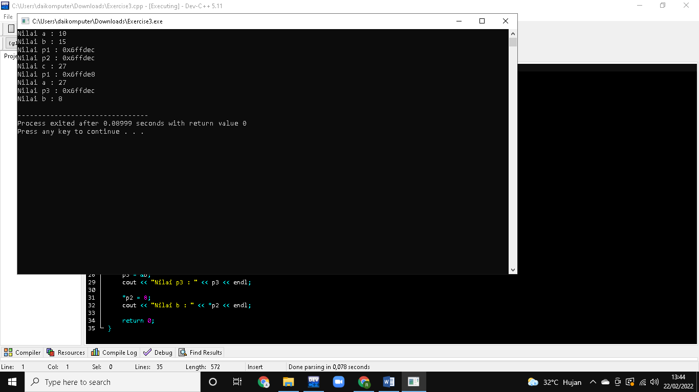

- Exercise 4

What Is The Output?

|  |  |  |  |  |  |
| --- | --- | --- | --- | --- | --- |
| a | b | c | p1 | p2 | p3 |
| 10 | 15 | 27 | 0x6ffdf4 | 0x6ffdf0 | 0x6ffdf0 |
| 27 | 6 | 27 |  |  | 0x6ffdec |
| 15 |  |  |  |  |  |

